CROSS BROWSER TESTING

You can test Cross Browser just by adding some code in wdio.conf.js File.

Here’s the documentation : <https://webdriver.io/docs/crossbrowsertesting-service/>

1. Open the wdio.conf.js File
2. Look for the capabilities
3. Then put the some of the browser that you have.
4. 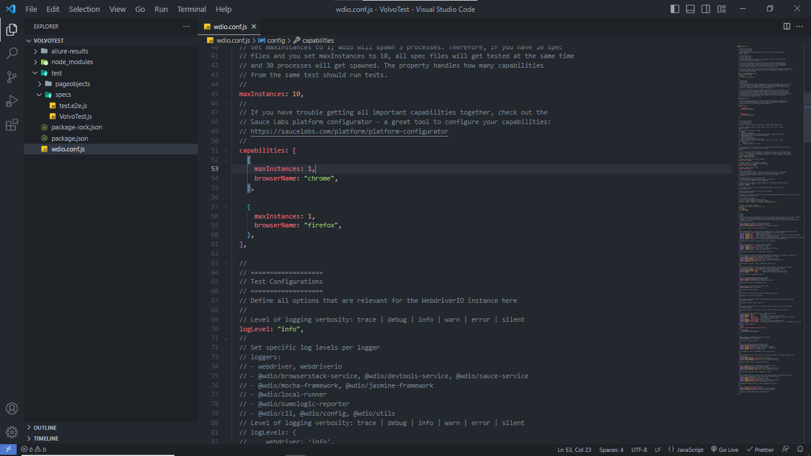On my side I’m using windows and I do have an Microsoft Edge but It has having an issue on version so I just put the Mozilla firefox. You can add the Safari if you’re using Mac OS or Apple OS.

Parallel testing - We are using Parallel testing to test different kinds of files and cross browser testing.

Type in the Terminal of the WebdriverIO Project  
For example you have a smoothScroll.JS File and newWindows.JS File  
So you will use spec to specify the file that you want to run.

npx wdio run .\wdio.conf.js --spec .\test\specs\smoothScroll.js --spec .\test\specs\newWindow.js

Because if we test it one by one each file and each browser it will consume us lot of time. Specially if you're dealing multiple files.

So by using Parallel testing it will save us a lot of time because we can test multiple files and different kinds of browser at the same time.

by setting the number of instances you want to run. MEANING number of browser sessions you want to create at one time and the reason we should set number or instances is because we dont want to be running unlimited number of sessions. At each time as new browser opens up it adds load to your system. So it means if your machine cannot handle running multiple browsers , then the test will start failing.

So you need to be careful on this things when you will run your test in server.

Decide how many instances you would like to run based on the server specs.

You don’t need to install Selenium Standalone service package anymore because It’s already included in the library of WebDriverIo. You’ll just need to add the browsers on the wdio.conf.js

